**Lab1_ANP-C7781**

**Solve below questions:**

1.Write a Java program to print "Hello, World!" to the console.

**Program :-**

package Day07;

import java.util.Scanner;

public class HelloWorld {

public static void main(String[] args) {

// This is normal defined string value to print on console

System.***out***.println("Hello,World!");

// Here we are taking string as an input and then print it on console

Scanner input = new Scanner(System.***in***);

System.***out***.print("Please Enter The Text/Sentence :- ");

// Taking input in str variable using input object

String str = input.nextLine();

System.***out***.println("Your input is :- " + str );

input.close();

}

}

**Output:-**

**-** **This output is normal defined string value to print on console**

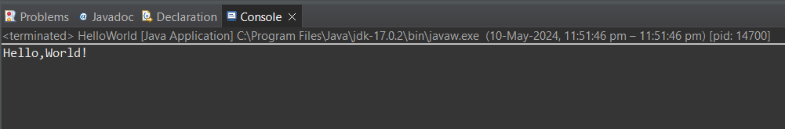

**-** **In this output, Here we are taking string as an input and then print it on console**

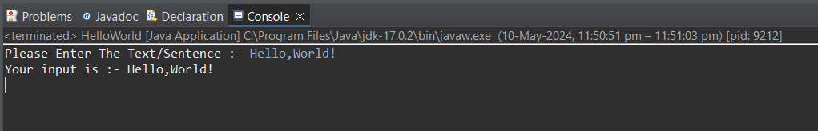

2.Write a program to find the sum of two numbers entered by the user.

Program :-

package Day07;

import java.util.Scanner;

public class Sum {

public static void main(String[] args) {

Scanner input = new Scanner(System.***in***);

// Taking 2 numbers as an input by user

System.***out***.println("Enter the first number :- ");

int num1 = input.nextInt();

System.***out***.println("Enter the second number :- ");

int num2 = input.nextInt();

// Perform operation on numbers

int result = num1 + num2;

System.***out***.println("The sum of the numbers :- " + result);

input.close();

}

}

**Output :-**

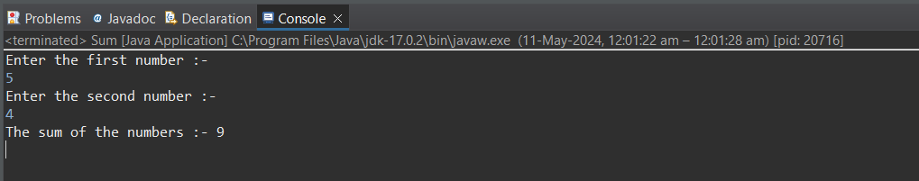

3.Write a Java program to check whether a given number is even or odd.

Program :-

package Day07;

import java.util.Scanner;

public class EvenOdd {

public static void main(String[] args) {

Scanner input = new Scanner(System.***in***);

// Taking input

System.***out***.print("Enter the number to check Even or Odd :- ");

int num = input.nextInt();

// Checking whether Number is Even or Odd

if(num%2 == 0) {

System.***out***.println("It's an Even Number");

}else {

System.***out***.println("It's an Odd Number");

}

}

}

**Output :-**

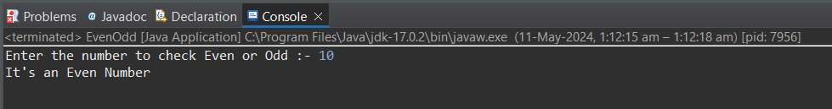

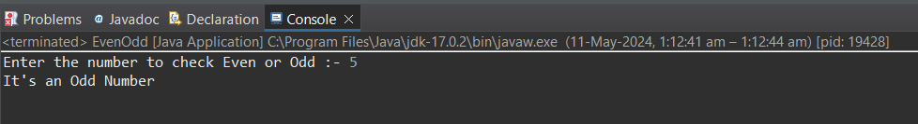

4.Write a java program to find greatest of 2 numbers.

Program :-

package Day07;

import java.util.Scanner;

public class GreatestNum {

public static void main(String[] args) {

Scanner input = new Scanner (System.***in***);

// Taking two numbers as an input

System.***out***.println("Enter first number:- ");

int Num1 = input.nextInt();

System.***out***.println("Enter first number:- ");

int Num2 = input.nextInt();

// Comparing two numbers to find greatest number

if(Num1 > Num2) {

System.***out***.println(Num1 +" is a greatest number");

}else {

System.***out***.println(Num2 +" ia a greatest number");

}

input.close();

}

}

**Output :-**

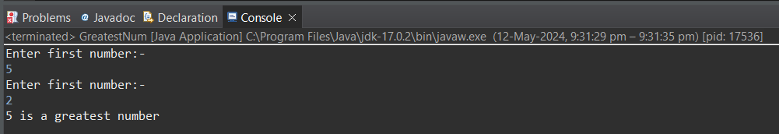

5.Write a program to implement a basic calculator that takes input as a string expression and evaluates it.

Program :-

package Day07;

import java.util.Scanner;

public class Calculator {

public static void main(String[] args) {

Scanner input = new Scanner (System.***in***);

// Taking two numbers as an input

System.***out***.println("Enter first number:- ");

int Num1 = input.nextInt();

System.***out***.println("Enter second number:- ");

int Num2 = input.nextInt();

// Asking about to enter the user choice

System.***out***.println("Select the Operator to Calculate the two numbers :-");

System.***out***.println("Enter 1 To Add");

System.***out***.println("Enter 2 To Subtract");

System.***out***.println("Enter 3 To Multiply");

System.***out***.println("Enter 4 To Divide");

// Taking choice as an input

int Operator = input.nextInt();

// Doing operations according to user's input/choice

if(Operator == 1) {

System.***out***.println(Num1+Num2);

}else if(Operator == 2) {

System.***out***.println(Num1-Num2);

}else if(Operator == 3) {

System.***out***.println(Num1*Num2);

}else if(Operator == 4) {

System.***out***.println(Num1/Num2);

}

input.close();

}

}

**Output :-**

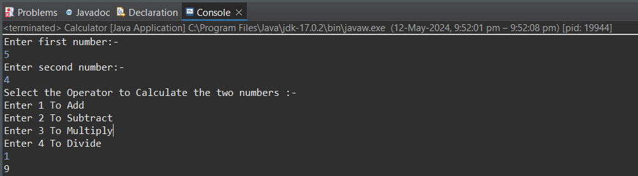

6.Write a Java program to check if a given number is even or odd.

7.Create a Java program that compares two numbers and prints the larger one.

**(This two questions are repeated)**

8.Write a Java program that takes an age input from the user and determines if they are eligible to vote (considering the legal voting age).

Program :-

package Day07;

import java.util.Scanner;

public class VotingEligibility {

public static void main(String[] args) {

Scanner input = new Scanner(System.***in***);

System.***out***.println("Enter the age to check the Eligibility for Voting :- ");

int age = input.nextInt();

if(age >= 18) {

System.***out***.println("You are eligible to vote");

}else {

System.***out***.println("You are not eligible to vote");

}

input.close();

}

}

**Output :-**

